**Depot Vehicle Allocation**

***Work-flow to Use Depot Vehicle Allocation***

Use **Load Template** to set up the preference. Only one instance of this preference may be used. Two templates are available, one of which is an extension of the other.

***Preference Overview***

This name of this preference is something of a misnomer. It deals with vehicle depot cir- cularity.

***Templates Available from Optibus***

*Table 1-1: Templates Summary*

|  |  |  |
| --- | --- | --- |
| **Template Name** | **Purpose** | **Reference** |
| Advanced depot optimization | Determines vehicle depot circularity. Setting this requires limiting optimization iterations. | **Advanced depot optimization** |
| Vehicle depot cir- cularity - default | Determines vehicle depot circularity | **Vehicle depot cir- cularity - default** |

***Advanced depot optimization***

**Purpose:**

Determines vehicle depot circularity (vehicles must return to their start depots at the end of a vehicle trip block). Setting this requires limiting optimization iterations.

**Prerequisites:** None.

**Opening Dialog:**

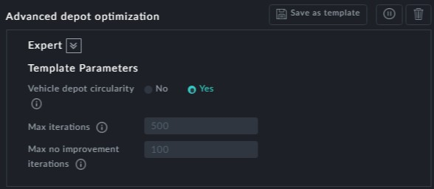

**Points to note:**

**Vehicle depot circularity** is set to Yes by default with the two maximum iteration counts as shown. If you disable circularity, the iteration items are ignored.

***Vehicle depot circularity - default***

**Purpose:**

Determines vehicle depot circularity (vehicles must return to their start depots at the end of a vehicle trip block).

**Prerequisites:** None.

**Opening Dialog:**

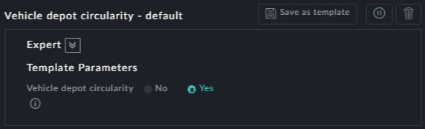

**Points to note:**

This is a short form of the previous template.



If you wish to set **Vehicle depot circularity** to Yes, use the previous tem-

plate.